Video games sales and ratings 1976 - 2016

**By Shahar Levi**

**John Bryce – Data Analyst Expert – July 2021**

**9297.10**

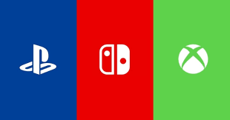

**Introduction**

Video games broke out into our lives in the early 70's with the two dimensional classic game 'Pong'.

Since then this industry kept growing and changed the way people spend their free time. More companies came into play and competed for more market domination. Thanks to this competition and the developing technology more consoles were released and graphics became more realistic. From the classic Magnavox Odyssey to today's Xbox and Playstation we can witness the huge transformation the gaming industry made.

In this project I would like to investigate the changes that have taken place in the gaming industry in terms of sales and popularity, escpecially the differences between the 3 main markets (North America, Europe and Japan).

I analyzed and visualized the data using Python Jupyter Notebook with Pandas Matplotlib and Seaborn libraries.

**Data Description**

**Choosen dataset:**

Video game sales from Vgchartz and corresponding ratings from Metacritic 1976-2016.

**Data Source:**

<https://www.kaggle.com/rush4ratio/video-game-sales-with-ratings>

This dataset contains a list of video games with sales greater than 100,000 copies released between 1976 and 2016. Unfortunately, there are missing observations as Metacritic only covers a subset of the platforms. To combat this, I created two new dataframes: one for analysis of sales, and one for scores.

Sales – 17,403 entries with no missing data in terms of name, platform, year, genre, publisher, or sales. Missing some score data.

Scores – 7,112 entries with no missing data whatsoever.

**Research Questions**

1. How have video games sales changed over time?
2. Sales distribution of the 3 main markets (North America, Europe and Japan) overtime.
3. Sales difference between 3 main markets by game, publisher and platform.
4. Differences between top selling games for PC and the consoles (PS4 and Xbox One).
5. How did users and critics rate top selling genres?
6. What are the top rated game genres by critics and users?

**Data Analysis and Results**

1. **How have video games sales changed over time?**

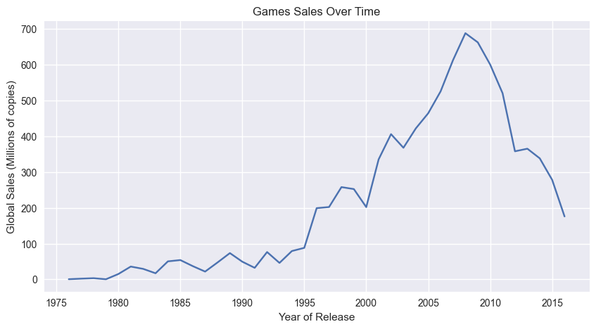

The data shows a huge increase since the 1980s, with multiple sales spikes over the years that are usually accompanied by the release of a new console or consoles. For example, Sony’s PlayStation 2 was released in the year 2000, and Nintendo and Microsoft released both their GameCube and the original Xbox at the end of 2001. The availability of these three major consoles resulted in the biggest year to date for video games, with almost 400 million games sold in 2002. Later, we’ll dig deeper into the most popular consoles and their best-selling games.

The major decline starting in 2009 may have multiple explanations. [Some experts](https://latimesblogs.latimes.com/entertainmentnewsbuzz/2011/01/2010-video-game-sales-from-npd.html) believe it to be a result of an uncertain economy, with the financial crisis of 2007–2008 causing consumers to reduce unnecessary spending. [Others](https://www.marketwatch.com/story/video-game-sales-expected-to-show-more-weakness-2010-01-13) blame saturation in the gaming industry, with a lack of fresh new games and consoles to keep customers interested. I also believe that the introduction of digital game sales through platforms like Steam and Epic Games contributed highly to the decline we’re seeing in terms of physical copies sold.

1. **Sales distribution of the 3 main markets (North America, Europe and Japan) overtime.**

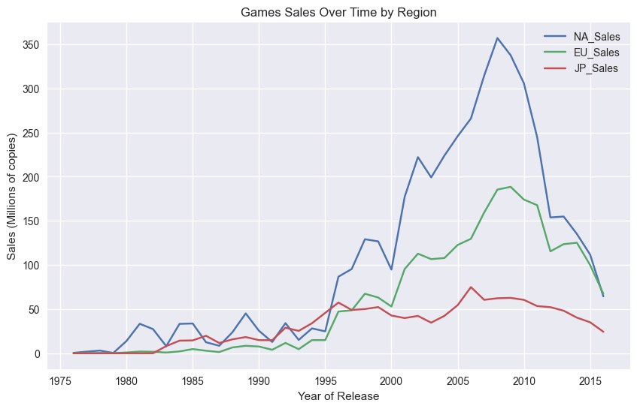

The North America market has the largest share of global sales mostly because it includes USA, reaching a peak of more than 350 million copies sold in 2008 right before the financial crisis.

For comparison the european market reached a peak of less than 200 million copies sold (almost 2 times less the North America) and the japanese matrket reached 70 million copies (5 times less than North America).

Those gaps are understandable because I have compared between country with population of 125 million people to huge continents with combined population of more then 1 billion people. But I still think those gap are to big. Let's go into a deeper analysis in order to understand what cause those big gaps between the regions.

1. **Sales difference between 3 main markets by game, publisher and platform.**

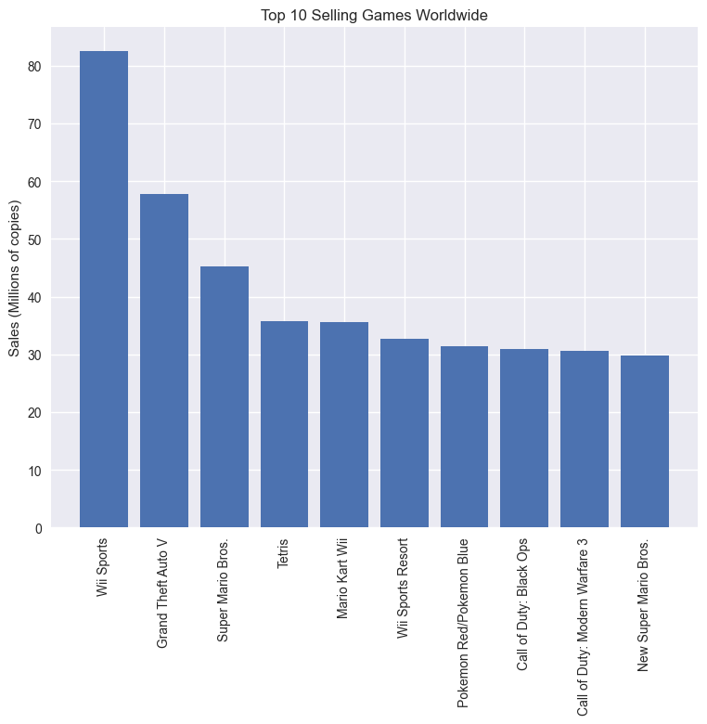

Wii Sport is the most selling game across all platforms with more than 80 million copies sold worldwide. Other famous titles like Grand Theft Auto, Call of Duty, Super Mario are also appear in this graph.

I want to analyze the top selling games by region in order to see if there is a difference between each region sales.

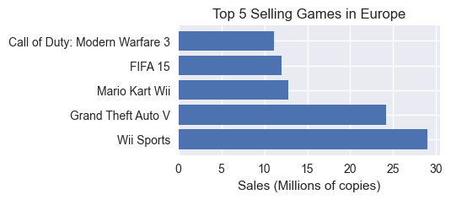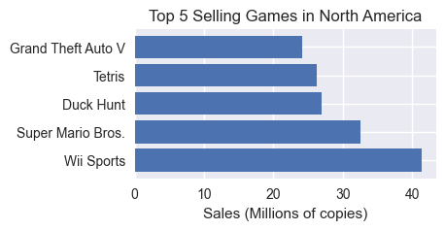

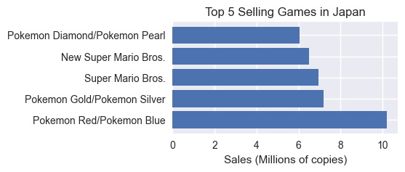

The graphs above show that popular franchise games like GTA, FIFA and Call of Duty sold more copies in Europe and North America. On the other hand it seems like the most popular games in Japan belong to the Pokemon franchise that has been released to the DS platform.

Another insight is that games with multiplayer mode that have longer "shelf life" are more popular in Europe and North America. Publisher release multiplayer content on a regular basis and that increase sales and popularity of the games.

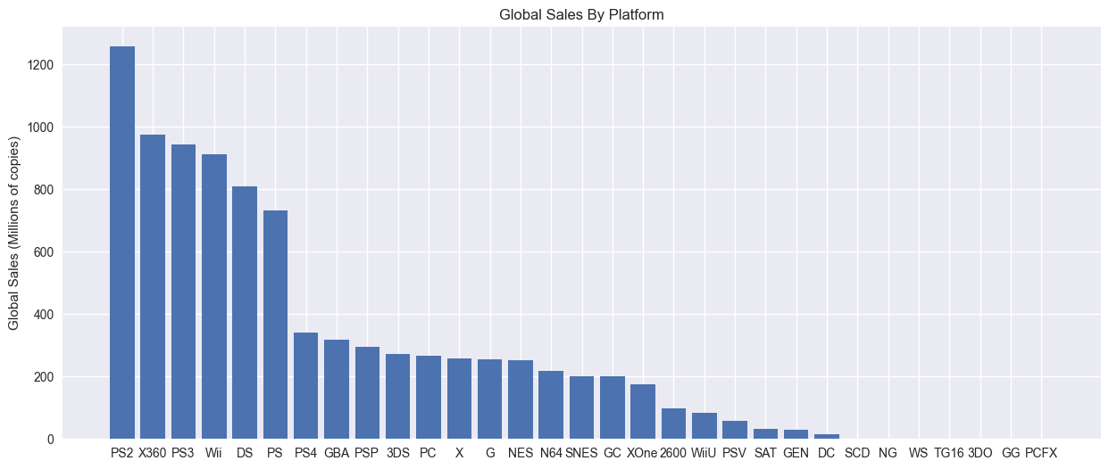

Sony, Microsoft and Nintendo are dominating the global market with their consoles while Sony PS2 that was released in 2000 has bypassed 1.2 billion games copies sold leaving its main competitor – the original Xbox far behind.

Let's see if there is a difference between the regions.

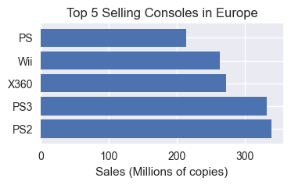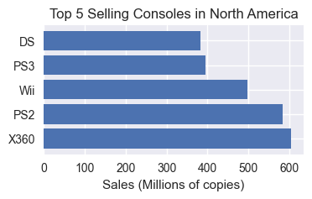

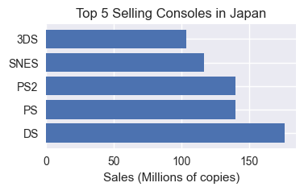

The top 5 consoles in North America and Europe are almost the same. Xbox 360 receive more popularity in the American market while the Europeans prefer Sony consoles and Nintendo Wii reaches an honorable place between them.

But again we see the differences in the Japanese taste in games with a huge popularity for the portable consoles of Nintendo – DS, 3DS and the old SNES.

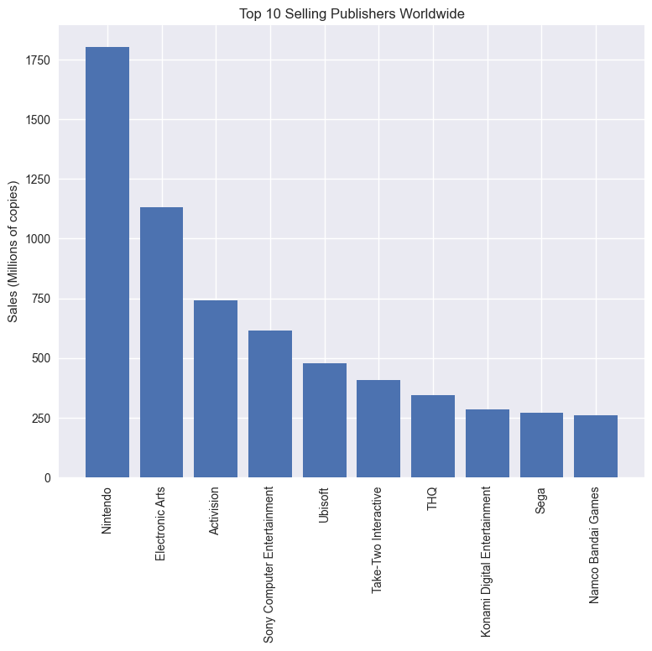

When it comes to publishers Japan gets a respectable share in sales with Nintendo leading the market with almost 2 billion copies sold worldwide. But apparently Japanese big publishers like Nintendo and Sony sell more games in the foreign market. Let's have a look at the numbers.

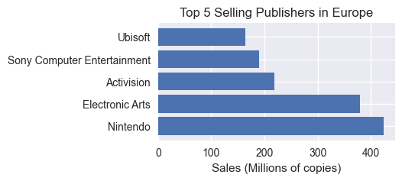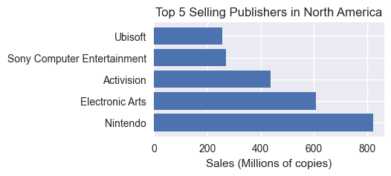

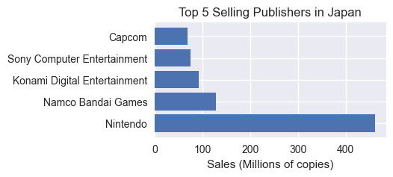

Nintendo is the top selling publisher in all 3 main markets thanks to their successful Wii console to which they released exclusive sports games that changed the way people played video games.

At the same time we can see that American publishers like EA and Activision did not reach the top 5 publishers in Japan which mean less popular games like Call of Duty series and FIFA were sold there.

1. **Differences between top selling games for PC and the consoles (PS4 and Xbox One).**

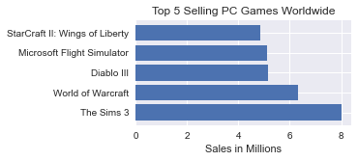

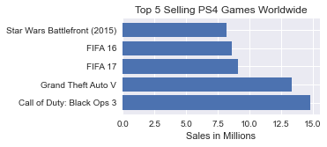

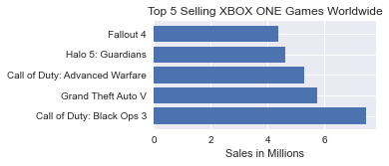

In this analysis we set out to discover if there is a difference in title preference between the latest iterations of gaming consoles (Xbox One ,PS4) and the PC .

According to the Graphs we can observe a difference in prefrence amongst users on different platforms.

Xbox users have a preference for shooting games according to the top 5 Selling Xbox Titles.

PS4 seems to harbor fans of the FIFA franchise.

PC is the platform where aging titles are continuously popular with the majority being Role-Playing games, this could be due to the average PC User's aging hardware and inability to run the newest titles which can be found in the Console's top selling trend.

All of PC's best selling titles are inaccessible on console.

1. **How did users and critics rate top selling genres?**

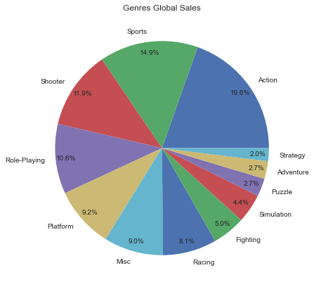

We can notice that the most popular genres are basicly the same as in our previous analysis.

In this analysis I would like to see the differences between critic ratings and user ratings for the top 5 selling genres worldwide.

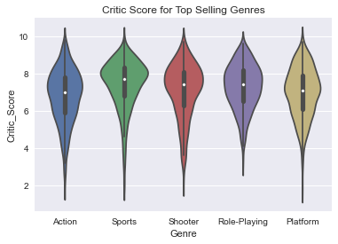

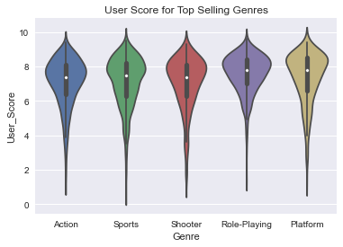Users tend to rate Platform and Role Playing games higher then critics and it looks like all other genres win sympathy from both users and critics. Let's analyze the most popular genres by users and critics.

1. **What are the top rated game genres by critics and users**

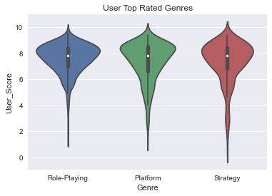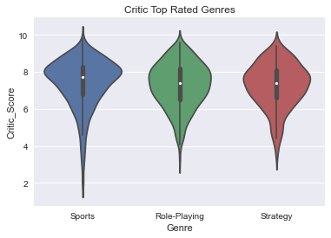

Critics and users alike tend to score strategy and role playing games very highly, but critics are more likely to enjoy sports games.

**Conclusions**

The Japanese market is not part of the global trend and it seems like the Japanese consumer has unique taste that differentiate him from the American and European consumers.

The western consumers prefer popular shooting and action franchise such as Call of Duty and Grand Theft Auto while the Japanese consumer tend to prefer platform and role playing games.

There is a huge differences in prefrences between PC gamers and console gamers. Role playing games that are inaccessible on consoles are the most popular on PC and on the other hand action and shooting games sold more copies on consoles.

Another insight is that critics and users have similar taste and they both rated platform and strategy with high ratings so we couldn't noticed much of a difference between their prefrences.

As we saw, westren consumers and Japanese consumer have different taste in terms of genres. We can figure the same conclusion in terms of consoles prefrences because Japanese consumers most popular games are exclusive for their most popular consoles.